The Duke Depot
CS 347 Design Report
Team 3: Aaron Zamecnik, Chris Brinkmann, Charles Humphries, and Michael Smith
11/01/2014

Introduction:

We have designed a web-based e-commerce store. This website uses a thin client-server architecture, with the browser residing on the Client end, and the Web Server Business Logic and MySQL database residing on the server. The site will be written in HTML, and also uses Java Servlets. CSS will be used to provide style for our pages. We chose to use the Model-View-Controller design pattern for this website. The Model component contains information regarding the user database, including the user’s profile information and the user’s respective shopping cart. The View component contains the various .jsp files that present the user interface to the customer. The Controller component contains the various java servlets that send transactions and commands to the Model and determines which jsp pages should be displayed by the View component.
This store sells JMU memorabilia and apparel and must be able to monitor users and their shopping carts as well as reliably process transactions. Users will be able to browse the store’s catalog, add and remove items from their shopping cart easily, make purchases via credit/debit cards and maintain a secure customer profile. This profile contains their payment information, billing and shipping addresses, order history, and personal data. A person is not required to have an account to place an order, but anonymous order information is still saved and can be retrieved.
Our site will rely heavily on dynamic content. Our user interface contains a navigation bar including a sign-in button located at the top of each page that will be displayed if an anonymous user is browsing the catalog or a welcome message, a “View Profile” button, and a shopping cart indicator if they are signed in. The site content will also be dynamic. Each product category page will pull from a table of products that contains a description, title, price, sizing options, and category; each product detail page will also be a template with interchangeable product information fields. This will allow site administrators to add and remove content through a GUI rather than interacting with the database or HTML pages directly, and will reduce the amount of time and resources needed to edit the product manifest. User profile pages will also be dynamically generated with specific profile information. The shopping cart will also be dynamically generated since it can change at any point in time.

Revised Use Case Diagram and Descriptions:

- Reset Password:
Abstract: A registered user will be able to reset the password to their account by answering security questions which they have previously set.
Precondition: The user has previously registered and knows their account name, and the answer to their account's security question.
Postcondition: The user's account password is reset to a new value. Users and shibboleth databases are updated.
Steps:
  - The user navigates to the password reset page (PasswordReset.jsp), by clicking a link from the main page (index.jsp).
  - PasswordReset.jsp displays a field for entering the account name.
  - The user enters the account name that they want to reset the password for.
  - The security question set up for that account is displayed, and the user must type the correct answer into the field.
  - PasswordReset.jsp displays a field for entering the new desired password.
  - The user enters their new desired password, and clicks a submit button, causing the password to be reset to the new value.
Alternatives:
cc1. The user enters an account name that does not match any in the database. Return to step b.
dd1. The user enters an incorrect answer to the security question. Repeat step d.

- Delete Account:
Abstract: A registered user or administrator will be able to remove their account (or another's account if the user is an administrator) from the system.
Precondition: The user is registered and logged in to their account
Postcondition: A user's account is removed from the Users, Payment Info, and Shibboleth databases.

Steps:
  - The user clicks on the Profile link (profile.jsp) from the main page (index.jsp).
  - The user clicks on the Delete Account link on their profile page.
  - The page displays a message prompting the user to confirm or cancel their action.
  - The user confirms, and they are returned to index.jsp, logged out, and their account is deleted from the user databases.
Alternatives:
aa1. The user is an administrator and is deleting another user's account.
aa2. The user clicks on the UserList (userList.jsp) link from the main page (index.jsp).
aa3. The user locates the account to be deleted and clicks on the Delete Account link.
aa4. The account is removed from all user Database's and the user remains on UserList.jsp.

- Change Account Information:
Abstract: A registered user will be able to change any profile information.
Precondition: The user is registered and logged in to their account
Postcondition: Some of the user's profile information has been changed
Steps:
  - The user clicks on the Profile link (profile.jsp) from the main page (index.jsp).
  - The user clicks on any of the edit links for payment information, billing and shipping addresses, personal information (name, age, gender).
  - The is presented with a blank text field to enter the appropriate information.
  - The user clicks a submit field and the information is updated in the User databases and displayed in the profile page.
Alternatives:

- View Account List:
Abstract: An administrator will be able to view the list of accounts registered to Duke Depot.
Precondition: The user is logged in to an administrator account.
Postcondition: The user can view a list of all registered accounts.
Steps:
  - The user clicks on the AccountList link (accountList.jsp) from the main page (index.jsp).
  - The user is taken to the account list page and can view all registered accounts.
Alternatives:
aa1. The user is not logged in or is not an administrator. In this case clicking the AccountList link will redirect back to the homepage (index.jsp).

- Browse Products:
Abstract: Any site visitor will be able to view the product catalog.
Precondition: The user has a working internet connection and web browser.
Postcondition:The user can browse available products on the Duke Depot website.
Steps:
  - The user navigates to www.DukeDepot.com on their web browser.
  - The user clicks on the products link (products.jsp).
  - The available products are displayed for the user to browse on products.jsp.
Alternatives:

- Place Order:
Abstract: Any site visitor will be able to place an order.
Precondition: The user has a working internet connection, web browser, and valid credit card information.
Postcondition: The user place's an order on the site, and the databases reflect that the user's are to be charged, and shipped the items that they ordered.
Steps:
  - The user navigates to www.DukeDepot.com on their web browser.
  - The user clicks on the link for the category they want to shop in (i.e. men's clothes, women's clothes, accessories, etc.) (category.jsp).
  - The user clicks on a specific product that they want to buy.(product.jsp)
  - The user selects any options available (size, color)
  - The user clicks "Add to Cart" button.
  - The user clicks on the "Checkout" link (checkout.jsp)
  - The user enters their shipping, billing, and credit card information.
  - The user clicks on the submit order button.
  - The databases are updated with the users orders.
Alternatives:
gg1. The user has a registered account and is logged in. They can select their saved shipping, billing, and credit card information from a drop down menu rather than re entering it.
gh1: The user enters invalid credit card information (incorrect number of characters [actual account information will not be validated until later]).
gh2: They are redirected to checkout.jsp.

- Create Account:
Abstract: Anonymous visitors will be able to create an account.
Precondition: The user has navigated to the main page of our website (www.DukeDepot.com).
Postcondition: The user has created an account that is recorded in our User database.
Steps:
  - The user clicks on the Create Account link (CreateAccount.jsp)
  - The user is taken to CreateAccount.jsp where they are presented with fields for account name, password, secret question, and answer to secret question.
  - The user fills in all of the necessary fields and clicks the submit button.
  - The account is created in the database and can be logged into using the credentials provided in step b.
Alternatives:

- View Account:
Abstract: Users can view their account information: name, age, gender, billing, shipping, and payment information.
Precondition: The user is registered and logged in to their account.
Postcondition: The user is able to see their account information.
Steps:
  - The user clicks on the Profile link (Profile.jsp) from the main page (index.jsp).
  - The user can see their profile information.
Alternatives:
aa1. The user is not logged in when they click on the Profile link.
aa2. The user is redirected back to index.jsp

- Add/Remove Content:
Abstract: Administrators will be able to add new product categories and products without having to edit raw HTML or interact directly with the database.
Precondition: The user is logged in to a registered administrator account.
Postcondition: The user has edited the content by adding, removing, or changing certain objects contained in the database.
Steps:
  - The user clicks on the Edit Products link (EditProducts.jsp) from the main page (index.jsp).
  - The user can edit any text field that describes any product. They can click on a link to remove a product from display and from the database.
  - The user can click on an Add link which will create a new set of fields to describe a new product which they can fill in (name, price, sizes, picture [jpeg], description, category)
Alternatives:

- View Orders:
Abstract: An administrator is able to view a list of all current and past orders contained in the order database.
Precondition: The user is logged in to a registered administrator account.
Postcondition: The administrator can see a list of the orders.
Steps:
  - The user clicks on the View Orders link (orderList.jsp) from the main page (index.jsp)
  - The user can see a list of all current and past orders contained in the order database.
Alternatives:
aa1. The user is not logged in or is not an administrator account when they click View Orders.
aa2. They are redirected back to the main page (index.jsp).

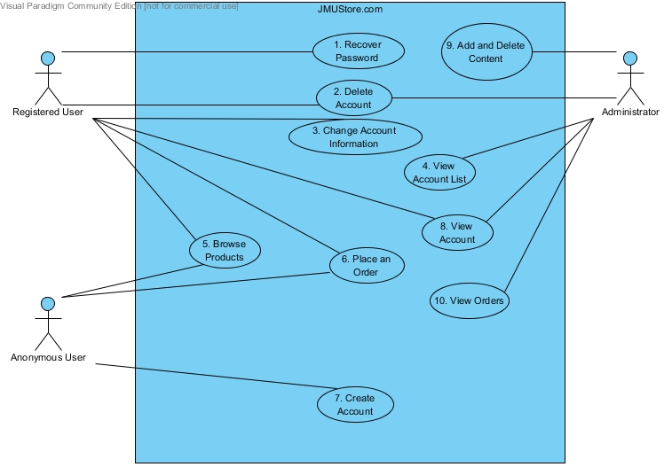
Figure : Use-Case Diagram for JMUStore.com

User Interface Standard:
For our user interface we decided to have a standard navigation bar for every page. The three main elements that will be included on the navigation bar are “Home”, “Contact”, and “Log In”. Since our site relies heavily on dynamic content, there will be slight changes to the navigation bar as the user maneuvers through different pages. For example, when the user first visits the home page, they will see the “Log In” button. After the user logs in, the “Log In” button will change to “Log Out”. Other buttons – such as checkout and view cart – will follow a similar manner based upon which page the user is on and if they are logged in. Our home page will display our logo (still under construction) then greet the user. A table of categories will be displayed below for the user to browse. When the user clicks on a category, another table is displayed with items from that category. For example, if the user clicks on JMU Hoodies as the category, a table of different hoodies is displayed. The user can then click on an item to view the description, size, and price information. From here the user can add this item to their shopping cart.
When the user clicks log in, they will be taken to another page where they are prompted for their username and password. They will have the options to submit, create a new account, or recover their password.
We are using a purple and yellow color scheme throughout our site. Our content will be primarily centered. We will use CSS to create a proper navigation bar (padding, removal of text-decorations, hover link color, visited color, etc.), align the tables (including all pictures and captions), and to make our user interface nice and clean.
The following images are mock-ups and still under construction:
Home Page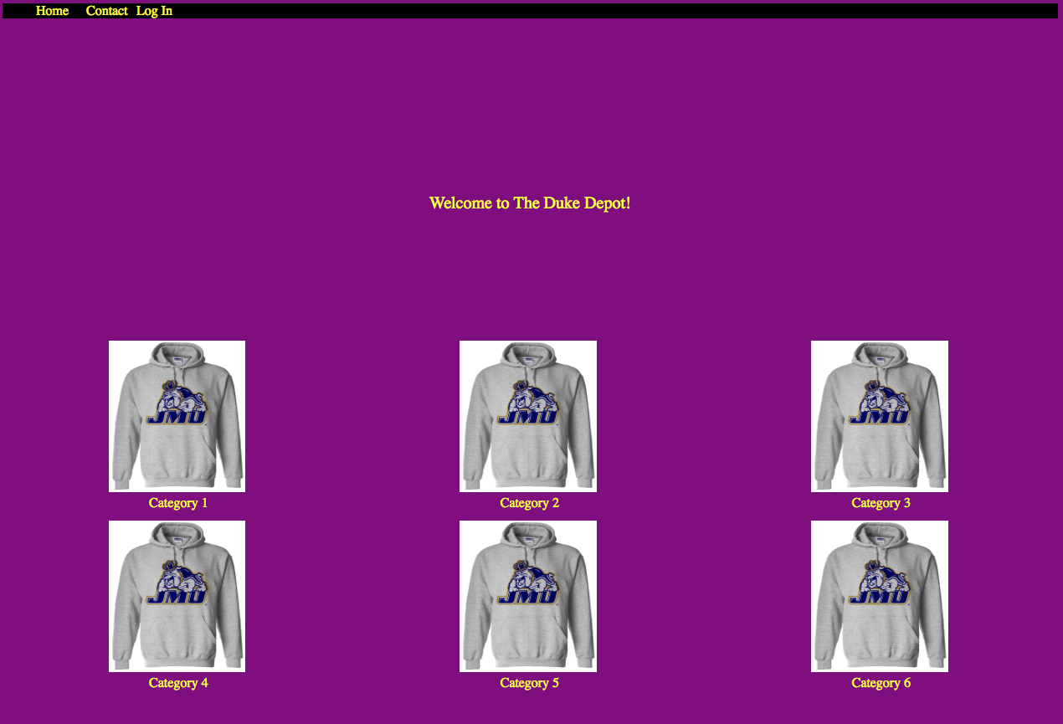
Log In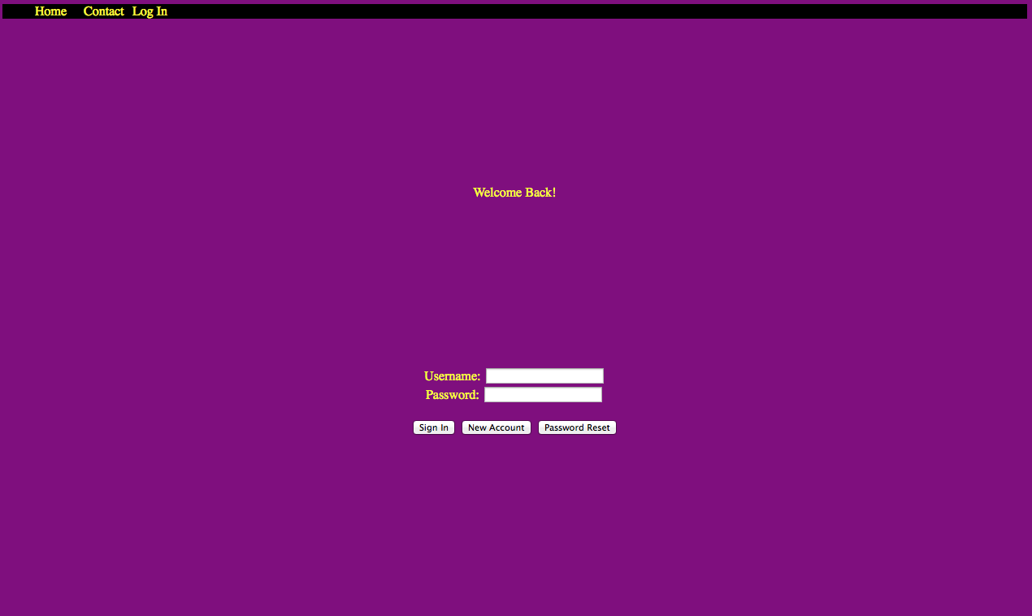

Individual Item
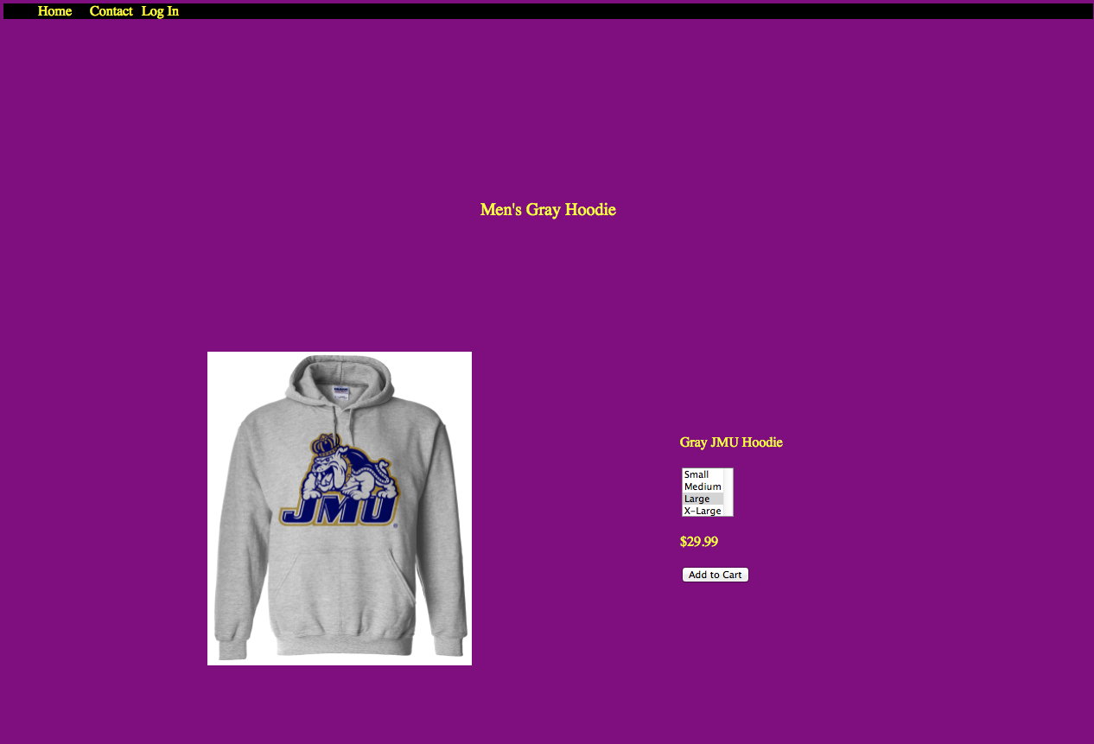

All other pages will follow a similar look and design.

Deployment Diagram:
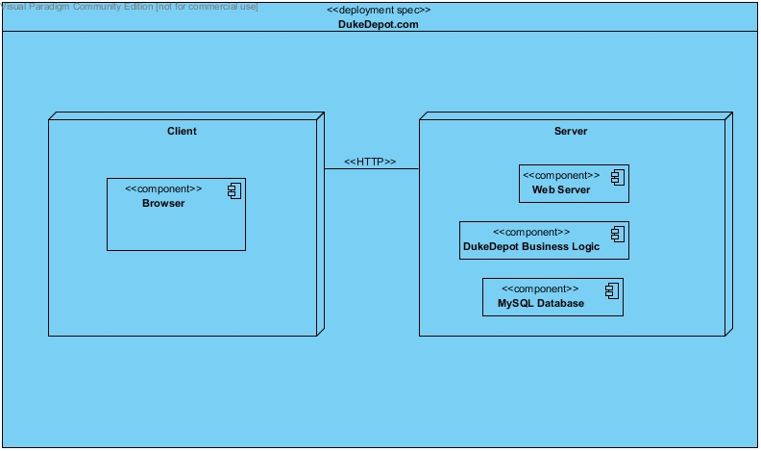
Component Diagram:
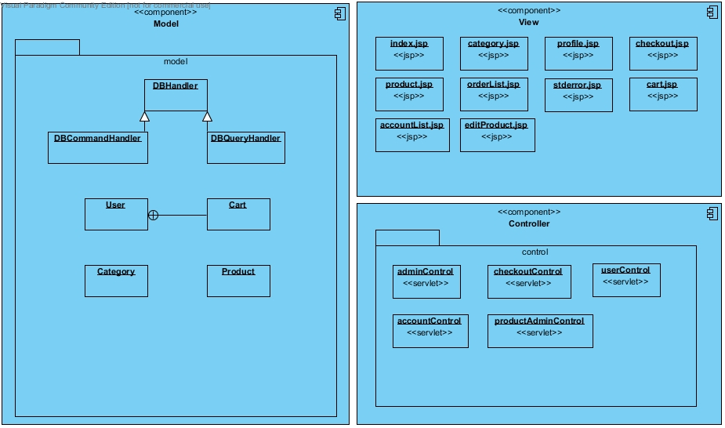
Database Tables

Users - this table stores all of the user accounts for the website.
Field Name | Type | Constraints | NULL? | Description
userID (PK) | INT | Unique. Auto-increment. | No | PRIMARY KEY. A unique integer to identify each user.
firstName | VARCHAR(20) |  | No | User's first name.
lastName | VARCHAR(20) |  | No | User's last name.
dob | VARCHAR(10) |  | Yes | User's date of birth.
shipAddress | VARCHAR(100) |  | Yes | User's shipping address.
gender | CHAR(1) |  | Yes | User's gender.
age | INT |  | Yes | User's age.
isAdmin | BOOLEAN |  | No | Determines whether user has administrator privileges.
userName | VARCHAR(20) | Unique. | No | A unique user name for each user to log in with.
password | BLOB | Encrypted | No | A password used to log in.
secretQuestion | BLOB | Encrypted | No | A secret question that the user can answer if they forget their password.
secretAnswer | BLOB | Encrypted | No | The answer to the secret question that can be used to log in if a user forgets their password.

Product Table - this table stores the information about each product offered in our online store.
Field Name | Type | Constraints | NULL? | Description
productId | INT | Unique. Auto-increment. | No | PRIMARY KEY. A unique integer to identify each product.
productName | VARCHAR(25) |  | No | The name of the product.
price | FLOAT |  | Yes | The price of the product in USD.
size | VARCHAR(3) |  | Yes
description | VARCHAR(50) |  | Yes | A description of the product.
image | BLOB |  | Yes | An image of the product.
category | VARCHAR(20) |  | Yes | FOREIGN KEY. Which product category the product is in.

Product Category - This table stores the different categories that each of the products are in.
Field Name | Type | Constraints | NULL? | Description
categoryId | INT | Unique. Auto-increment | No | PRIMARY KEY. A unique integer to identify each product category.
categoryName | VARCHAR(30) |  | No | The name of the product category.

Payment Information - This table stores sets of credit card payment information. Each entry is mapped to a particular userID.

Field Name | Type | Constraints | NULL? | Description
paymentID | INT | Unique. Auto-increment. | No | PRIMARY KEY. A unique integer to identify each set of payment credentials.
userID | INT |  | No | FOREIGN KEY. The userID associated with the paymentID.
cardType | VARCHAR(15) |  | No | The type of credit card (Visa, Mastercard, American Express, etc.)
cvv | BLOB | Encrypted. | No | Credit card verification value.
cardNumber | BLOB | Encrypted. | No | The credit card number.
expDate | BLOB | Encrypted. | No | The expiration date of the credit card.
nameOnCard | BLOB | Encrypted. | No | The name that appears on the credit card.
billingAddress | BLOB | Encrypted. | No | The billing address associated with the credit card.

Products in Cart - This table contains all of the products in user's shopping carts and are each mapped to a particular userID.

Field Name | Type | Constraints | NULL? | Description
userID | INT |  | No | FOREIGN KEY. The user ID associated with the particular item in the shopping cart.
productID | INT |  | No | FOREIGN KEY. The id number of the product being purchased.
size | VARCHAR(2) |  | Yes | The size of the product - S, M, L, or XL.
color | VARCHAR(15) |  | Yes | The color of the product selected by the user.
Quantity | INT |  | No | The quantity of items of productID to be purchased.

